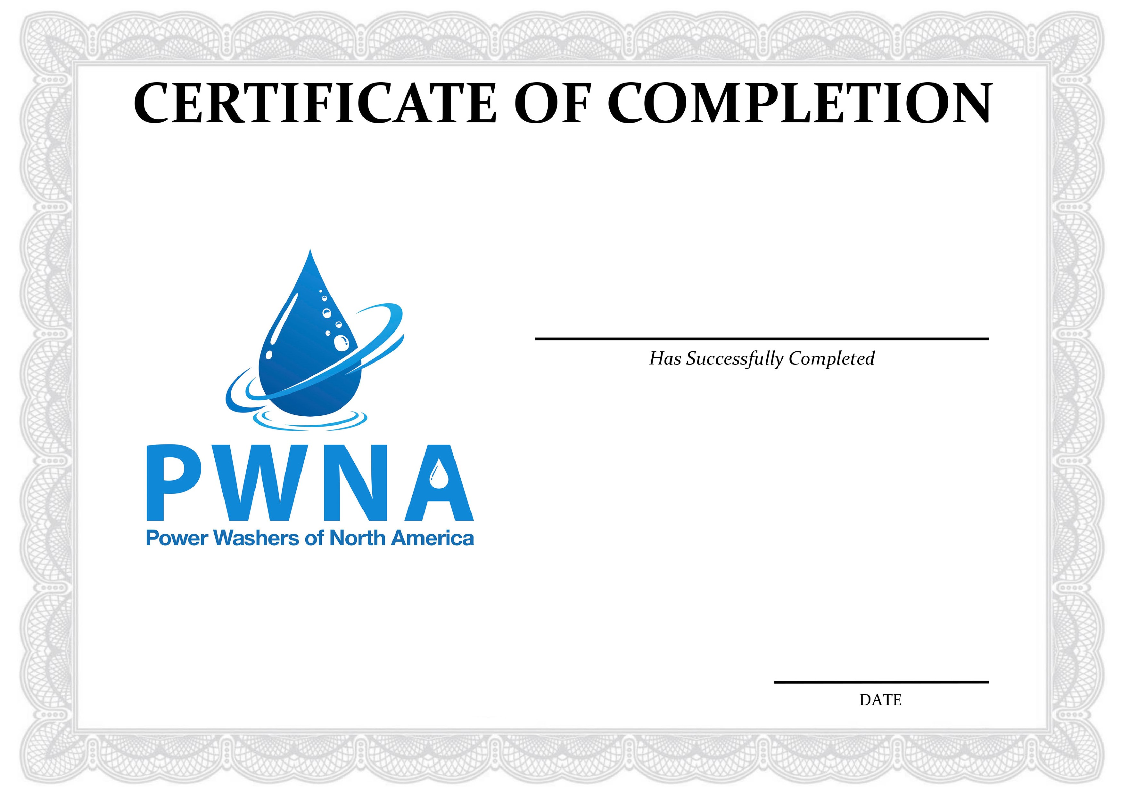

**Aaron Deines**

The Window Cleaning Specialists

**Respiratory Training**

*Delivered: 04/29/2020*

*(*

*exp.*

*04/29/2021)*